CS696F Applied Software Testing
Test Summary Report
Vyom Raj, Ashraf Pinjari, Daanish Shaikh, and Shlok
Semester 4

Table of Contents
1. Purpose 3
2. Application Overview 3
3. Testing Scope 3
4. Metrics 4
5. Types of Testing Performed 4
6. Test Environment & Tools 5
7. Lessons Learnt 5
8. Recommendations 6
9. Best Practices 6
10. Exit Criteria 6
11. Conclusion / Sign-Off 6
12. Definitions, Acronyms, and Abbreviations 6

1. Purpose
The purpose of this Test Summary Report is to summarize the testing activities performed by Team members across Cycles 1, 2, and 3 and to present the overall quality results for the assigned Xero modules. This report consolidates execution outcomes, observed defects, coverage at the story/module level, and key lessons learned during testing.

2. Application Overview
Xero is a cloud-based accounting platform used by businesses to manage invoicing, accounts receivable, accounts payable, purchase orders, reconciliations, and business reporting. The product supports a unified financial data model so users can create, review, search, and report on accounting records from a browser-based interface.
For this project, Team responsibilities focused on Modules 06 (Invoicing), 07 (Accounts Receivable), 08 (Purchase Orders), 11 (Accounts Payable), and 12 (Accounting Reports). Each team member owned one business module plus at least one related reporting story, with Cycle 3 placing additional focus on Invoicing quote workflows.

3. Testing Scope

a) In Scope
- 06. Invoicing —
- Creation and maintenance of invoice records, including new invoices, repeating invoices.
- Create quote and edit/update quote workflows.
- Approval Workflows for Invoices
- Integration of Invoices with accounts payable and receivables.
- 07. Accounts Receivable — receivable visibility and customer balance / outstanding invoice related features.
- 08. Purchase Orders —
- Purchase order drafting, creation, deletion/closure, and retrieval/search behavior.
- Approval workflows for purchase orders.
- Integration of purchase orders with inventory management and accounts payable.
- 11. Accounts Payable — supplier bill drafting/creation and payables-related validation.
- 12. Accounting Reports —
- Report generation and verification for invoice detail
- Receivable invoice summary, accounts receivable aging, accounts payable aging, balance sheet generation,
- Report outputs.

b) Out of Scope
  - Other application modules assigned to other teams.
  - End-to-End Testing: Testing system interfaces to external systems is out of scope as the team does not have access to the test environments of the external systems.
  - Performance Testing: This includes load testing and stress testing of the system under high volumes of transactions. These tests are not conducted at this stage and could be considered in a future testing cycle.
  - Security Testing: Specific security testing, such as penetration testing or vulnerability scanning, is not included in this phase of testing.

c) Items Not Tested / Constraints
- Some workflows were constrained by tenant behavior, role limitations, or missing cross-account visibility in the Xero demo company.
- Restricted-role entitlement comparisons could not always be executed because several test accounts behaved with similar access levels.
- Certain reporting or downstream validations depended on data being generated first in another module or on system behavior not fully controllable in the demo tenant.
- Cycle 3 focused on Invoicing-only user stories for Vyom Raj rather than pairing Invoicing with a Reporting story.

4. Metrics

a) Planned vs Executed vs Passed / Failed by Cycle
Cycle | Test Cases Planned | Test Cases Executed | Passed | Failed
Cycle 1 | 47 | 47 | 41 | 6
Cycle 2 | 40 | 40 | 40 | 0
Cycle 3 | 48 | 48 | 39 | 9
Total | 135 | 135 | 120 | 15

b) Defect Summary
Based on the qTest release defect summaries shared for the project, Release 1 contained 5 logged defects, Release 2 showed no logged defects, and Release 3 contained 4 logged defects, for a total of 9 logged defectsacross the combined effort
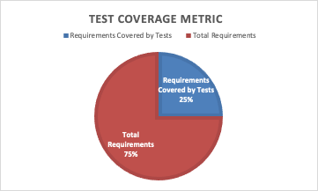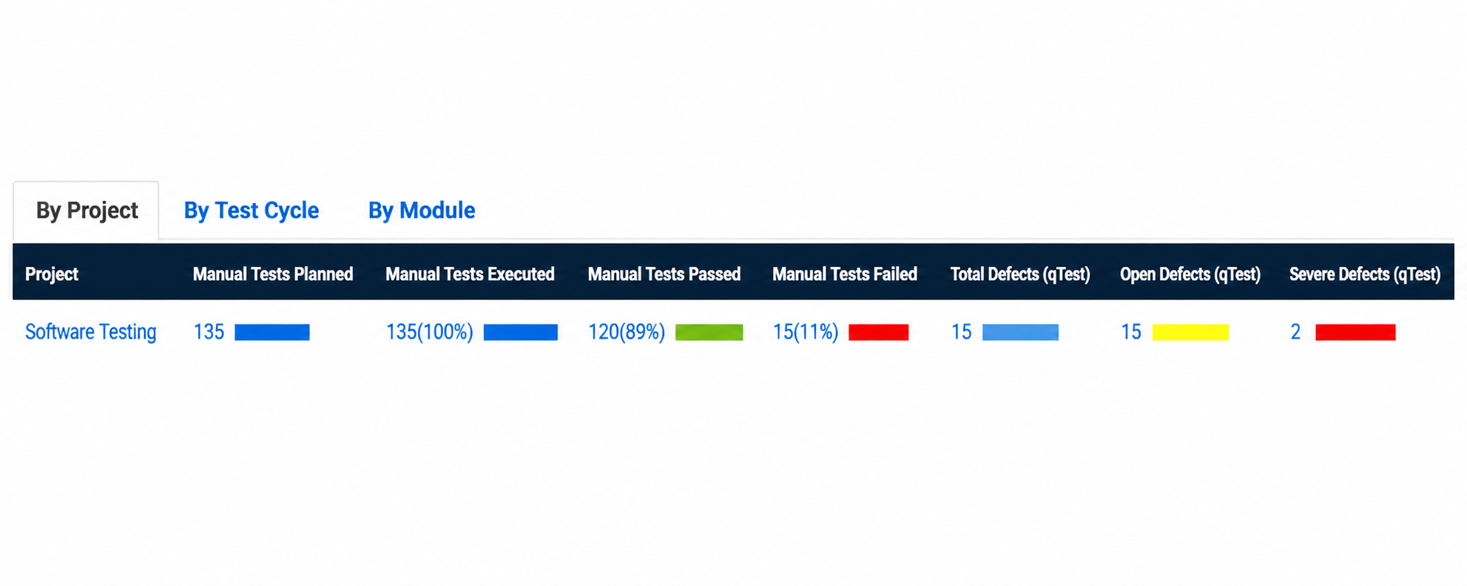
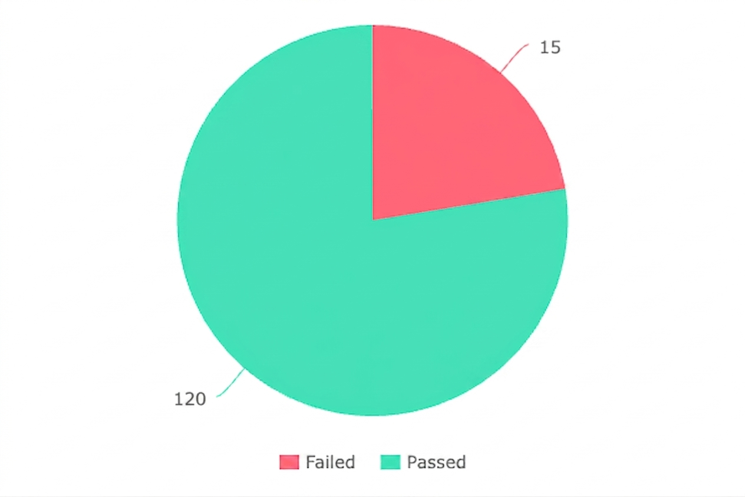
Release / Cycle | Logged Defects | Observed Status | Notes
Release 1 / Cycle 1 | 5 | New / Open | 1 High, 4 Medium based on shared screenshot
Release 2 / Cycle 2 | 0 | None observed | No failures reported in execution metrics
Release 3 / Cycle 3 | 4 | New / Open | 4 Medium based on shared screenshot
Total | 9 | Open at capture time | Counts based on qTest defect summaries shared by the team

c) Requirement / Story Coverage

Formal numeric requirement export was not available in the final source set. Coverage was therefore summarized at the assigned user-story and module level. All planned stories scheduled in Cycles 1, 2, and 3 were executed, and each assigned area of responsibility contributed to the combined execution totals listed above.

5. Types of Testing Performed
Functional Testing: Focused on validating core business behaviors in Invoicing, Accounts Receivable, Purchase Orders, Accounts Payable, and Accounting Reports.
GUI Testing: Verified screen layout, visible controls, date pickers, tables, filters, and list views across the assigned stories.
Field Validation / EP-BVA Testing: Applied to critical fields such as quantity, unit price, due dates, expiration dates, and required input components.
Data Dependency Validation: Validated business rules such as date dependencies and downstream availability of created records in retrieval/edit/report flows.
Data Flow Testing: Confirmed that data created in one story became available to downstream stories, such as Create Quote to Edit/Update Existing Quote and creation to report/retrieval flows.
Connectivity / Concurrency Testing: Executed selectively where supported by the story design, especially for update/save behavior and multi-session handling.
Regression Testing: Retested core flows during later cycles to ensure previously working behaviors were not unintentionally broken.

6. Test Environment & Tools
- Application Under Test: Xero cloud accounting system
- Environment: Xero Demo Company / non-production academic testing environment
- Primary Access Method: Web browser
- Browsers Used: Chrome and other modern desktop browsers as available to team members
- Operating Systems: Primarily desktop environments used by the team during coursework
- Test Management Tool: qTest
- Defect Management Tool: Jira / qTest defect tracking
- Reporting / Metrics Support: Tableau and qTest execution dashboards
- Supporting Collaboration: Team communication and peer review through shared class/team coordination channels

7. Lessons Learnt
S. No | Issue Faced | Resolution / Learning
1 | Documentation and formatting inconsistencies appeared early across test artifacts. | Using shared templates for test design, test cases, peer review packets, and qTest imports improved consistency.
2 | qTest import and requirement-linking issues slowed execution logging. | The team standardized file formats and corrected import-sheet values before re-uploading to qTest.
3 | Tenant limitations made some entitlement or downstream validations harder to execute. | The team adapted with ET-lite scenarios, careful assumptions, and explicit constraint notes in design artifacts.
4 | Some business-rule validations in Xero behaved unexpectedly, such as zero quantity, invalid price, or incorrect date dependencies being accepted. | These were captured as functional defects and used to strengthen later-cycle validation coverage.
5 | Peer review improved the clarity of steps and expected results before submission. | Independent execution by a teammate helped identify ambiguity and raised the quality of final test specifications.

8. Recommendations
- Standardize all templates before execution begins so test design, test cases, and qTest imports remain aligned.
- Validate tenant constraints and user-account behavior earlier in the cycle to avoid avoidable ET and DF assumptions.
- Export qTest and defect metrics regularly during the cycle rather than only at the end.
- Retest known defect-prone validation areas such as dates, quantities, and pricing whenever related stories are introduced in later cycles.
- Continue using peer review before final submission of test specifications.

9. Best Practices
- Prepare test design and detailed test case specifications before execution begins.
- Keep one field/dependency per validation test case to improve traceability and defect isolation.
- Link tests, defects, and requirements in qTest whenever possible to preserve traceability.
- Capture screenshots for key failures and unusual system behavior.
- Use module-wise ownership while still reviewing each other’s artifacts for clarity and completeness.

10. Exit Criteria
a) All planned test cases across Cycles 1, 2, and 3 were executed – Yes.
b) Defects identified during execution were logged and tracked in qTest/Jira – Yes.
c) Open defects remained at the time of summary capture, primarily in Release 1 and Release 3 – Yes; follow-up action would be required before any production-style sign-off.

11. Conclusion / Sign-Off
Based on the execution results, the team completed all planned testing for the assigned Xero modules and related reporting stories across Cycles 1, 2, and 3. Cycle 2 completed with all tests passing, while Cycles 1 and 3 surfaced meaningful validation and workflow defects that were documented and tracked. Accordingly, this report supports successful completion of the academic testing scope. Further UAT and business validation would still be recommended before any real deployment decision.

12. Definitions, Acronyms, and Abbreviations
- qTest – test management tool used for planning, execution, defect tracking, and metrics.
- Jira – issue and defect tracking platform used to record and manage bugs.
- UAT – User Acceptance Testing.
- URL – Uniform Resource Locator.
- Defect – any deviation from the expected behavior of the application found during testing.
- EP/BVA – Equivalence Partitioning / Boundary Value Analysis.
- FV – Field Validation.
- DDV – Data Dependency Validation.
- DF-In / DF-Out – data flow into / out of a downstream or upstream feature under test.
- STS – Status validation.
- CL – Calculations validation.
- ET – Entitlements / access-related behavior.
- CC – Concurrency testing.
- CN – Connectivity testing.

